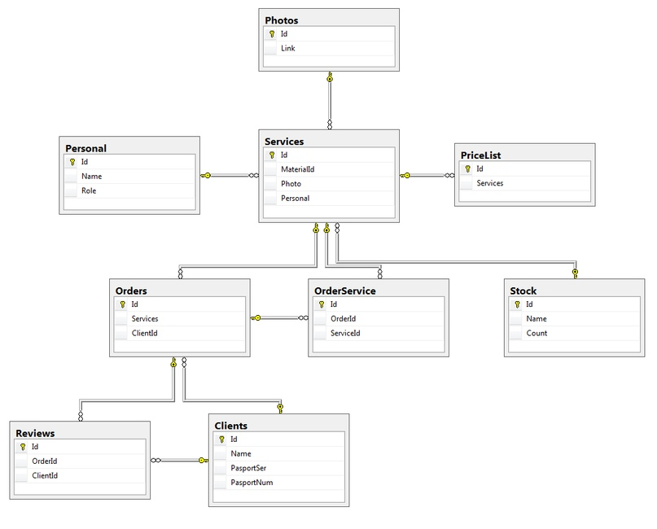

USE [master]

GO

/****** Object: Database [Houses] Script Date: 12/11/2018 15:45:06 ******/

CREATE DATABASE [Houses] ON PRIMARY

( NAME = N'Houses', FILENAME = N'C:\Program Files\Microsoft SQL Server\MSSQL10_50.SQLEXPRESS\MSSQL\DATA\Houses.mdf' , SIZE = 3072KB , MAXSIZE = UNLIMITED, FILEGROWTH = 1024KB )

LOG ON

( NAME = N'Houses_log', FILENAME = N'C:\Program Files\Microsoft SQL Server\MSSQL10_50.SQLEXPRESS\MSSQL\DATA\Houses_log.ldf' , SIZE = 1024KB , MAXSIZE = 2048GB , FILEGROWTH = 10%)

GO

ALTER DATABASE [Houses] SET COMPATIBILITY_LEVEL = 100

GO

IF (1 = FULLTEXTSERVICEPROPERTY('IsFullTextInstalled'))

begin

EXEC [Houses].[dbo].[sp_fulltext_database] @action = 'enable'

end

GO

ALTER DATABASE [Houses] SET ANSI_NULL_DEFAULT OFF

GO

ALTER DATABASE [Houses] SET ANSI_NULLS OFF

GO

ALTER DATABASE [Houses] SET ANSI_PADDING OFF

GO

ALTER DATABASE [Houses] SET ANSI_WARNINGS OFF

GO

ALTER DATABASE [Houses] SET ARITHABORT OFF

GO

ALTER DATABASE [Houses] SET AUTO_CLOSE OFF

GO

ALTER DATABASE [Houses] SET AUTO_CREATE_STATISTICS ON

GO

ALTER DATABASE [Houses] SET AUTO_SHRINK OFF

GO

ALTER DATABASE [Houses] SET AUTO_UPDATE_STATISTICS ON

GO

ALTER DATABASE [Houses] SET CURSOR_CLOSE_ON_COMMIT OFF

GO

ALTER DATABASE [Houses] SET CURSOR_DEFAULT GLOBAL

GO

ALTER DATABASE [Houses] SET CONCAT_NULL_YIELDS_NULL OFF

GO

ALTER DATABASE [Houses] SET NUMERIC_ROUNDABORT OFF

GO

ALTER DATABASE [Houses] SET QUOTED_IDENTIFIER OFF

GO

ALTER DATABASE [Houses] SET RECURSIVE_TRIGGERS OFF

GO

ALTER DATABASE [Houses] SET DISABLE_BROKER

GO

ALTER DATABASE [Houses] SET AUTO_UPDATE_STATISTICS_ASYNC OFF

GO

ALTER DATABASE [Houses] SET DATE_CORRELATION_OPTIMIZATION OFF

GO

ALTER DATABASE [Houses] SET TRUSTWORTHY OFF

GO

ALTER DATABASE [Houses] SET ALLOW_SNAPSHOT_ISOLATION OFF

GO

ALTER DATABASE [Houses] SET PARAMETERIZATION SIMPLE

GO

ALTER DATABASE [Houses] SET READ_COMMITTED_SNAPSHOT OFF

GO

ALTER DATABASE [Houses] SET HONOR_BROKER_PRIORITY OFF

GO

ALTER DATABASE [Houses] SET READ_WRITE

GO

ALTER DATABASE [Houses] SET RECOVERY SIMPLE

GO

ALTER DATABASE [Houses] SET MULTI_USER

GO

ALTER DATABASE [Houses] SET PAGE_VERIFY CHECKSUM

GO

ALTER DATABASE [Houses] SET DB_CHAINING OFF

GO

USE [Houses]

GO

/****** Object: Table [dbo].[Photos] Script Date: 12/11/2018 15:45:07 ******/

SET ANSI_NULLS ON

GO

SET QUOTED_IDENTIFIER ON

GO

CREATE TABLE [dbo].[Photos](

[Id] [int] NOT NULL,

[Link] [text] NOT NULL,

PRIMARY KEY CLUSTERED

(

[Id] ASC

)WITH (PAD_INDEX = OFF, STATISTICS_NORECOMPUTE = OFF, IGNORE_DUP_KEY = OFF, ALLOW_ROW_LOCKS = ON, ALLOW_PAGE_LOCKS = ON) ON [PRIMARY]

) ON [PRIMARY] TEXTIMAGE_ON [PRIMARY]

GO

/****** Object: Table [dbo].[Personal] Script Date: 12/11/2018 15:45:07 ******/

SET ANSI_NULLS ON

GO

SET QUOTED_IDENTIFIER ON

GO

CREATE TABLE [dbo].[Personal](

[Id] [int] NOT NULL,

[Name] [text] NOT NULL,

[Role] [text] NOT NULL,

PRIMARY KEY CLUSTERED

(

[Id] ASC

)WITH (PAD_INDEX = OFF, STATISTICS_NORECOMPUTE = OFF, IGNORE_DUP_KEY = OFF, ALLOW_ROW_LOCKS = ON, ALLOW_PAGE_LOCKS = ON) ON [PRIMARY]

) ON [PRIMARY] TEXTIMAGE_ON [PRIMARY]

GO

/****** Object: Table [dbo].[Clients] Script Date: 12/11/2018 15:45:07 ******/

SET ANSI_NULLS ON

GO

SET QUOTED_IDENTIFIER ON

GO

CREATE TABLE [dbo].[Clients](

[Id] [int] NOT NULL,

[Name] [text] NOT NULL,

[PasportSer] [text] NOT NULL,

[PasportNum] [text] NOT NULL,

PRIMARY KEY CLUSTERED

(

[Id] ASC

)WITH (PAD_INDEX = OFF, STATISTICS_NORECOMPUTE = OFF, IGNORE_DUP_KEY = OFF, ALLOW_ROW_LOCKS = ON, ALLOW_PAGE_LOCKS = ON) ON [PRIMARY]

) ON [PRIMARY] TEXTIMAGE_ON [PRIMARY]

GO

/****** Object: Table [dbo].[Stock] Script Date: 12/11/2018 15:45:07 ******/

SET ANSI_NULLS ON

GO

SET QUOTED_IDENTIFIER ON

GO

CREATE TABLE [dbo].[Stock](

[Id] [int] NOT NULL,

[Name] [text] NOT NULL,

[Count] [int] NOT NULL,

PRIMARY KEY CLUSTERED

(

[Id] ASC

)WITH (PAD_INDEX = OFF, STATISTICS_NORECOMPUTE = OFF, IGNORE_DUP_KEY = OFF, ALLOW_ROW_LOCKS = ON, ALLOW_PAGE_LOCKS = ON) ON [PRIMARY]

) ON [PRIMARY] TEXTIMAGE_ON [PRIMARY]

GO

/****** Object: Table [dbo].[Services] Script Date: 12/11/2018 15:45:07 ******/

SET ANSI_NULLS ON

GO

SET QUOTED_IDENTIFIER ON

GO

CREATE TABLE [dbo].[Services](

[Id] [int] NOT NULL,

[MaterialId] [int] NOT NULL,

[Photo] [int] NOT NULL,

[Personal] [int] NOT NULL,

PRIMARY KEY CLUSTERED

(

[Id] ASC

)WITH (PAD_INDEX = OFF, STATISTICS_NORECOMPUTE = OFF, IGNORE_DUP_KEY = OFF, ALLOW_ROW_LOCKS = ON, ALLOW_PAGE_LOCKS = ON) ON [PRIMARY]

) ON [PRIMARY]

GO

/****** Object: Table [dbo].[Orders] Script Date: 12/11/2018 15:45:07 ******/

SET ANSI_NULLS ON

GO

SET QUOTED_IDENTIFIER ON

GO

CREATE TABLE [dbo].[Orders](

[Id] [int] NOT NULL,

[Services] [int] NOT NULL,

[ClientId] [int] NOT NULL,

PRIMARY KEY CLUSTERED

(

[Id] ASC

)WITH (PAD_INDEX = OFF, STATISTICS_NORECOMPUTE = OFF, IGNORE_DUP_KEY = OFF, ALLOW_ROW_LOCKS = ON, ALLOW_PAGE_LOCKS = ON) ON [PRIMARY]

) ON [PRIMARY]

GO

/****** Object: Table [dbo].[PriceList] Script Date: 12/11/2018 15:45:07 ******/

SET ANSI_NULLS ON

GO

SET QUOTED_IDENTIFIER ON

GO

CREATE TABLE [dbo].[PriceList](

[Id] [int] NOT NULL,

[Services] [int] NOT NULL,

PRIMARY KEY CLUSTERED

(

[Id] ASC

)WITH (PAD_INDEX = OFF, STATISTICS_NORECOMPUTE = OFF, IGNORE_DUP_KEY = OFF, ALLOW_ROW_LOCKS = ON, ALLOW_PAGE_LOCKS = ON) ON [PRIMARY]

) ON [PRIMARY]

GO

/****** Object: Table [dbo].[Reviews] Script Date: 12/11/2018 15:45:07 ******/

SET ANSI_NULLS ON

GO

SET QUOTED_IDENTIFIER ON

GO

CREATE TABLE [dbo].[Reviews](

[Id] [int] NOT NULL,

[OrderId] [int] NOT NULL,

[ClientId] [int] NOT NULL,

PRIMARY KEY CLUSTERED

(

[Id] ASC

)WITH (PAD_INDEX = OFF, STATISTICS_NORECOMPUTE = OFF, IGNORE_DUP_KEY = OFF, ALLOW_ROW_LOCKS = ON, ALLOW_PAGE_LOCKS = ON) ON [PRIMARY]

) ON [PRIMARY]

GO

/****** Object: Table [dbo].[OrderService] Script Date: 12/11/2018 15:45:07 ******/

SET ANSI_NULLS ON

GO

SET QUOTED_IDENTIFIER ON

GO

CREATE TABLE [dbo].[OrderService](

[Id] [int] NOT NULL,

[OrderId] [int] NOT NULL,

[ServiceId] [int] NOT NULL,

PRIMARY KEY CLUSTERED

(

[Id] ASC

)WITH (PAD_INDEX = OFF, STATISTICS_NORECOMPUTE = OFF, IGNORE_DUP_KEY = OFF, ALLOW_ROW_LOCKS = ON, ALLOW_PAGE_LOCKS = ON) ON [PRIMARY]

) ON [PRIMARY]

GO

/****** Object: ForeignKey [FK__Services__Materi__0CBAE877] Script Date: 12/11/2018 15:45:07 ******/

ALTER TABLE [dbo].[Services] WITH CHECK ADD FOREIGN KEY([MaterialId])

REFERENCES [dbo].[Stock] ([Id])

GO

/****** Object: ForeignKey [FK__Services__Person__0EA330E9] Script Date: 12/11/2018 15:45:07 ******/

ALTER TABLE [dbo].[Services] WITH CHECK ADD FOREIGN KEY([Personal])

REFERENCES [dbo].[Personal] ([Id])

GO

/****** Object: ForeignKey [FK__Services__Photo__0DAF0CB0] Script Date: 12/11/2018 15:45:07 ******/

ALTER TABLE [dbo].[Services] WITH CHECK ADD FOREIGN KEY([Photo])

REFERENCES [dbo].[Photos] ([Id])

GO

/****** Object: ForeignKey [FK__Orders__ClientId__1CF15040] Script Date: 12/11/2018 15:45:07 ******/

ALTER TABLE [dbo].[Orders] WITH CHECK ADD FOREIGN KEY([ClientId])

REFERENCES [dbo].[Clients] ([Id])

GO

/****** Object: ForeignKey [FK__Orders__Services__1BFD2C07] Script Date: 12/11/2018 15:45:07 ******/

ALTER TABLE [dbo].[Orders] WITH CHECK ADD FOREIGN KEY([Services])

REFERENCES [dbo].[Services] ([Id])

GO

/****** Object: ForeignKey [FK__PriceList__Servi__1367E606] Script Date: 12/11/2018 15:45:07 ******/

ALTER TABLE [dbo].[PriceList] WITH CHECK ADD FOREIGN KEY([Services])

REFERENCES [dbo].[Services] ([Id])

GO

/****** Object: ForeignKey [FK__Reviews__ClientI__22AA2996] Script Date: 12/11/2018 15:45:07 ******/

ALTER TABLE [dbo].[Reviews] WITH CHECK ADD FOREIGN KEY([ClientId])

REFERENCES [dbo].[Clients] ([Id])

GO

/****** Object: ForeignKey [FK__Reviews__OrderId__21B6055D] Script Date: 12/11/2018 15:45:07 ******/

ALTER TABLE [dbo].[Reviews] WITH CHECK ADD FOREIGN KEY([OrderId])

REFERENCES [dbo].[Orders] ([Id])

GO

/****** Object: ForeignKey [FK__OrderServ__Order__276EDEB3] Script Date: 12/11/2018 15:45:07 ******/

ALTER TABLE [dbo].[OrderService] WITH CHECK ADD FOREIGN KEY([OrderId])

REFERENCES [dbo].[Orders] ([Id])

GO

/****** Object: ForeignKey [FK__OrderServ__Servi__286302EC] Script Date: 12/11/2018 15:45:07 ******/

ALTER TABLE [dbo].[OrderService] WITH CHECK ADD FOREIGN KEY([ServiceId])

REFERENCES [dbo].[Services] ([Id])

GO